# Subsetting NumPy Arrays in Python

Below is the image showing the exercise from DataCamp:

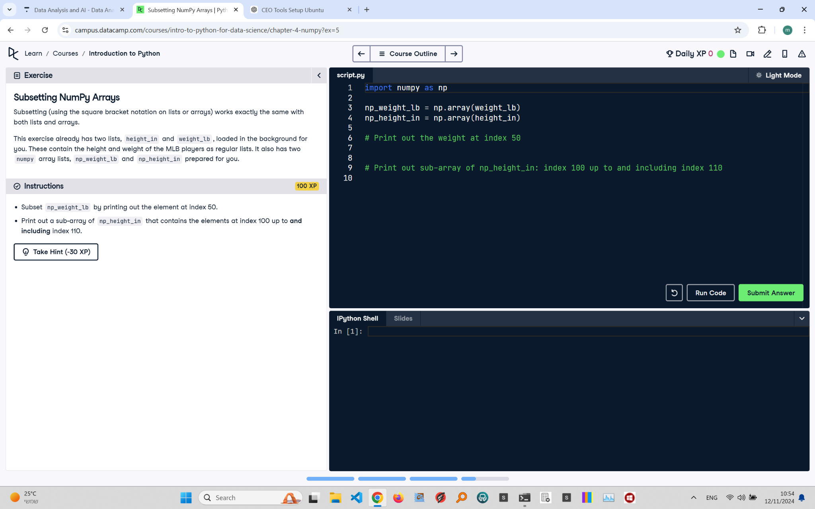

Exercise Explanation:

The exercise involves using subsetting techniques to extract specific elements from NumPy arrays. You need to print the element at index 50 of 'np_weight_lb' and then create and print a sub-array from 'np_height_in' between indices 100 and 110, inclusive.

Answer Code:

print(np_weight_lb[50])  
print(np_height_in[100:111])

Explanation of the Code:

We use square bracket notation for subsetting NumPy arrays. To print a single element, we specify its index, np_weight_lb[50]. For a sub-array, we use slicing: np_height_in[100:111] extracts elements from index 100 to 110 (inclusive), as the upper bound in slicing is exclusive.